Approve an order

IBS Order approval steps

BOR approval

Confirmation

Report manufacturing orders

Pick List

Print

Confirm

Package Reporting

Table

# 

# 

# IBS Order approval steps

The follow are the steps through the IBS system to approve an order. Each phase can be viewed by the client through the web and we use each of the different statuses to inform the client of their order’s status through the IBS system.

## BOR approval

You can manually manipulate the BOR operations. The main reason we do this is to place the order in a status for further handling in the system.

### Confirmation

So the order has to be in an approved status, 20. From VPI online you confirm the order or from the IBS client you can use “Work with sales orders”. You can only confirm and approve the proof using VPI all of the other approval phases are performed in IBS.

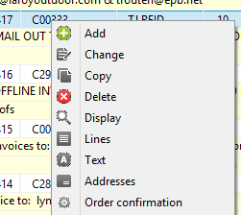Right click the order and select “Order confirmation”.

Once you have the order at a status of 20 go to the order line and locate the MFG number on the “Additional info 2” tab in the “BtB/IRO” section. Then you can perform the following steps.

* Report manufacturing orders
* Print the Pick List.
* Confirm the Pick list.
* Report the Package.

### Report manufacturing orders

So let’s see how we do this. Report each of the different operations as complete for the MFG number you found on the sales order tab from above.

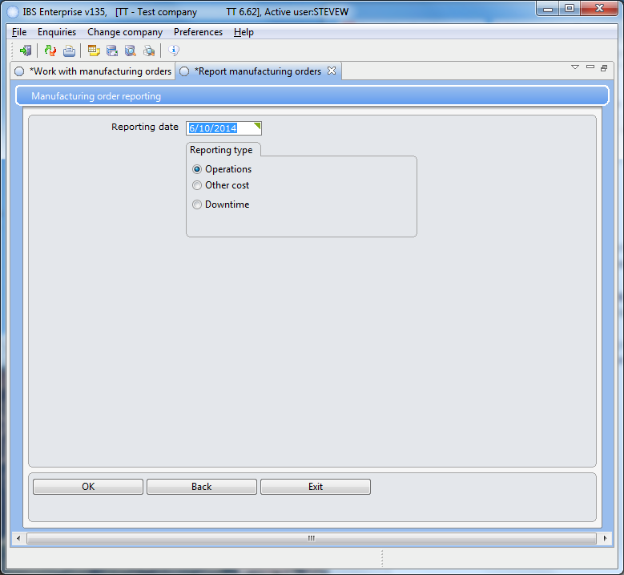 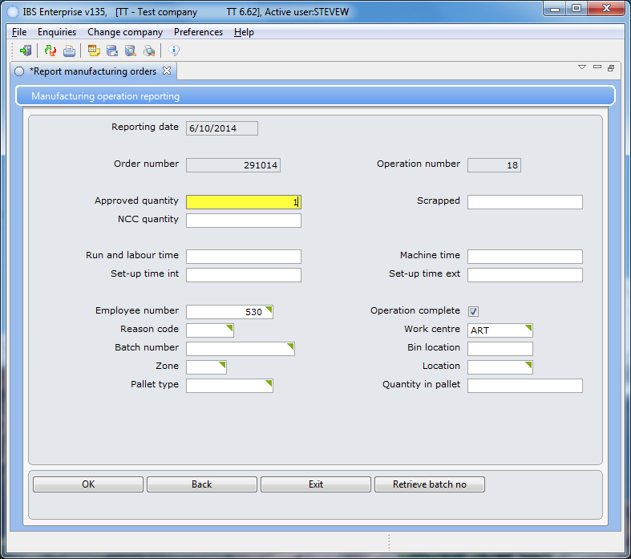You need to enter the order number, operation, quantity, and an employee number. Each box has help dialog boxes to select from lists. Make sure to check the “Operation complete” box or else TJ will look at you cross-eyed.

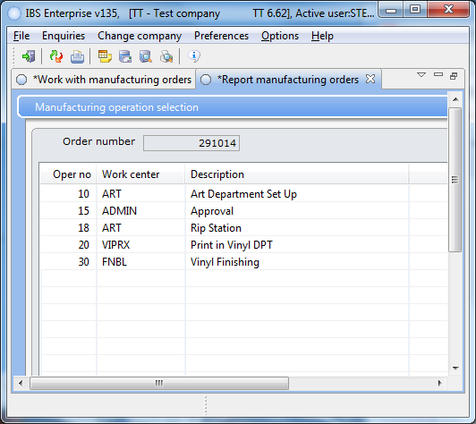 MFG number 291014 has five operations to select from and we must complete each to move to the next phase of approval.

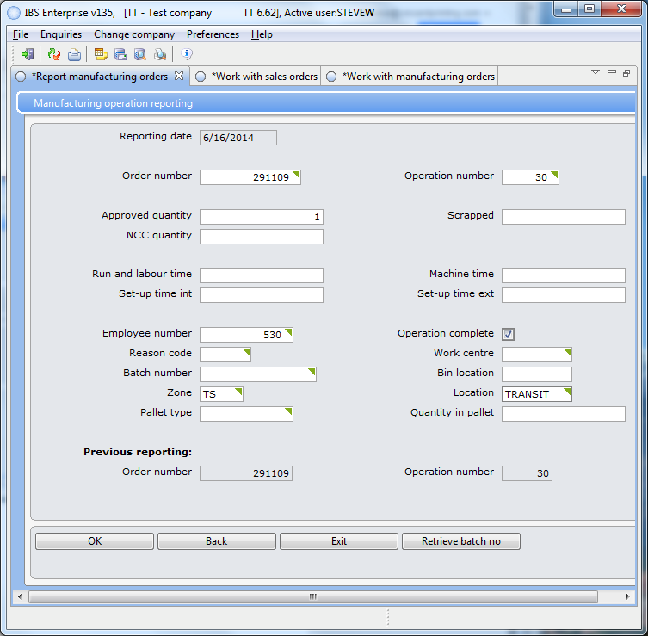For the last operation you will need to enter the Zone and Location.

## Pick List

### Print

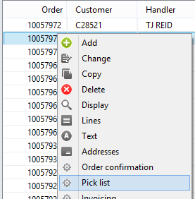 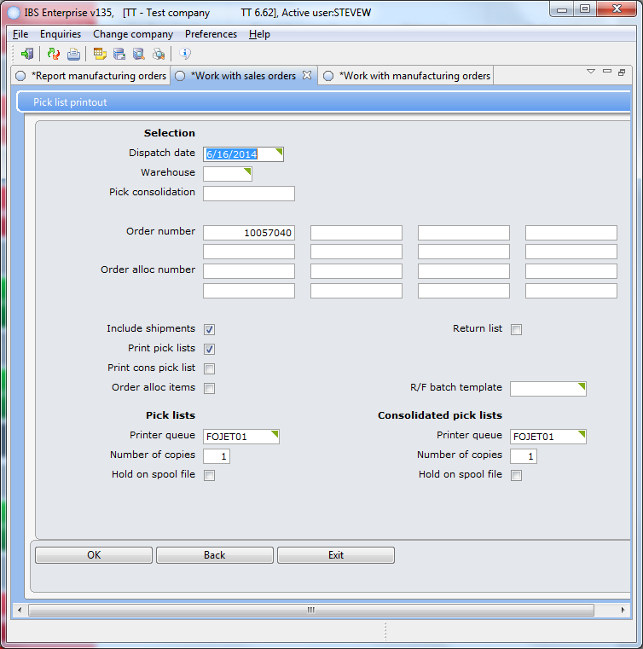Select Print the pick list by right-clicking on the sales order and enter “FOJET01” for your printer. The report has the pick list number on it.

### Confirm

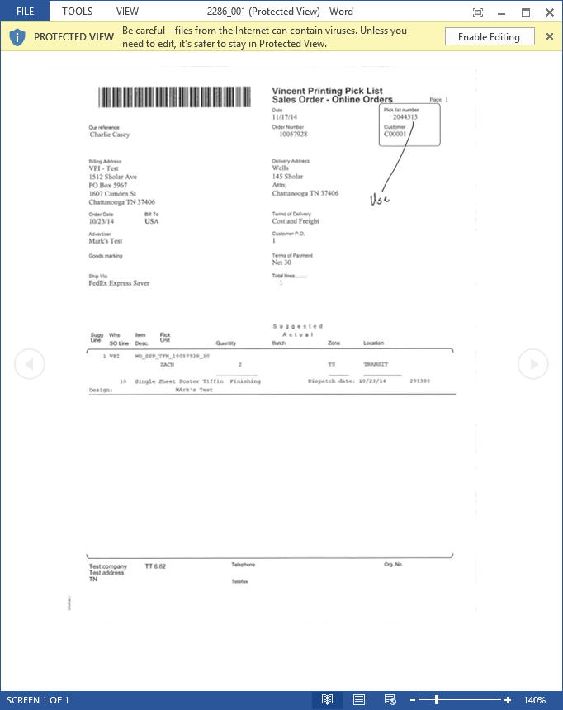

Using the Pick list number confirm the pick list using “Confirm sales order pick lists”.

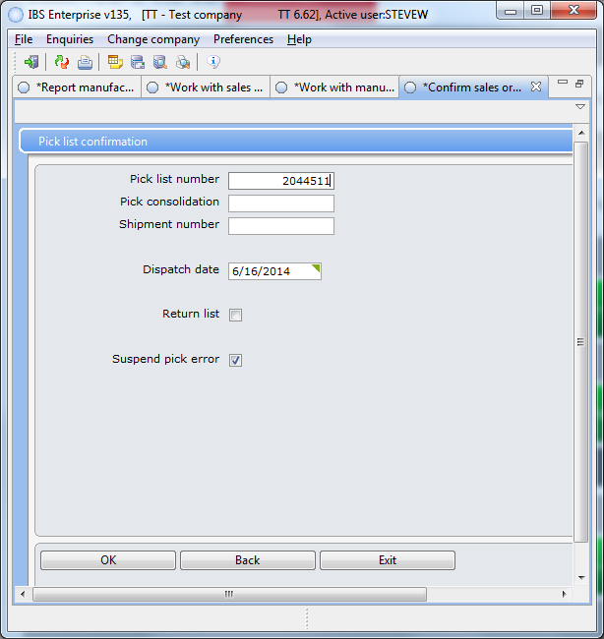

Once you have gotten the order to this point the on-line should show your orders

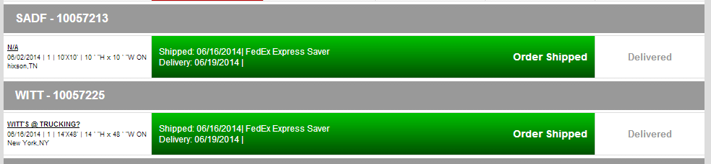

as shipped.

## Package Reporting

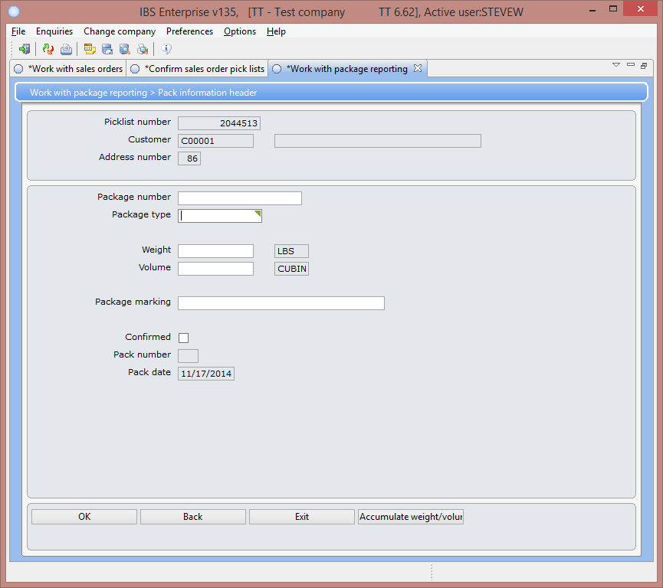 The next step is to use the “Working with package reporting” to enter fedex data into the Z3OPTRH table using the pick list number. Note: We use the text “delivered” in the “Package marking” field as a tag to let the logic know that this order was not delivered by Fedex or UPS. The logic will treat this entry as a completed entry for this order.

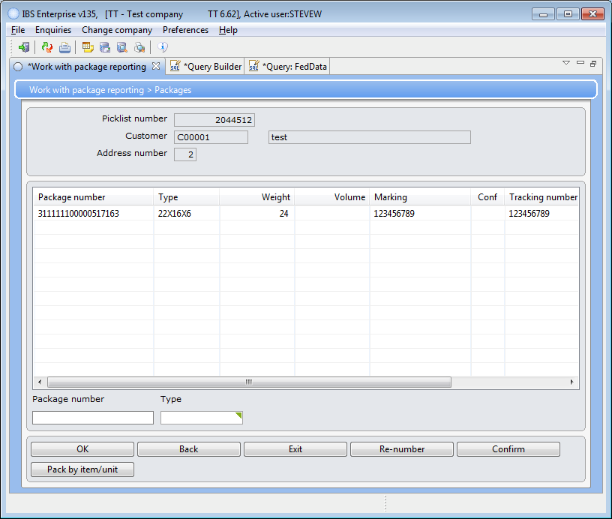Now that we have the pick list number we can add information about the shipping to complete this phase.

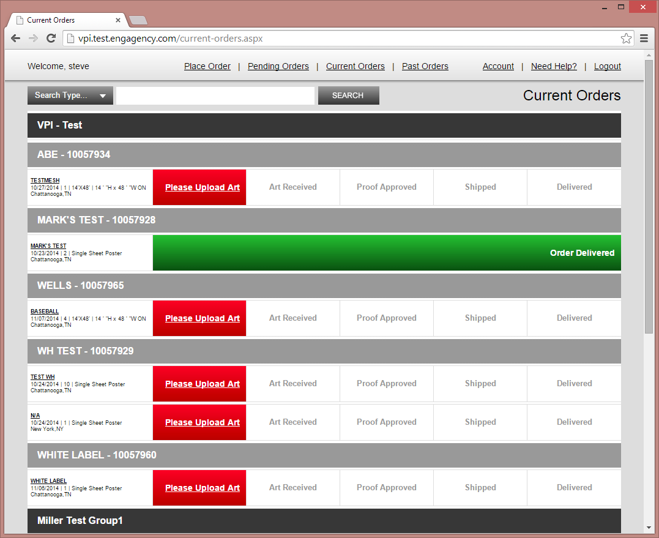

And that completes the approval of the order through both IBS and the web.

## Table

We can view the package data in the table.

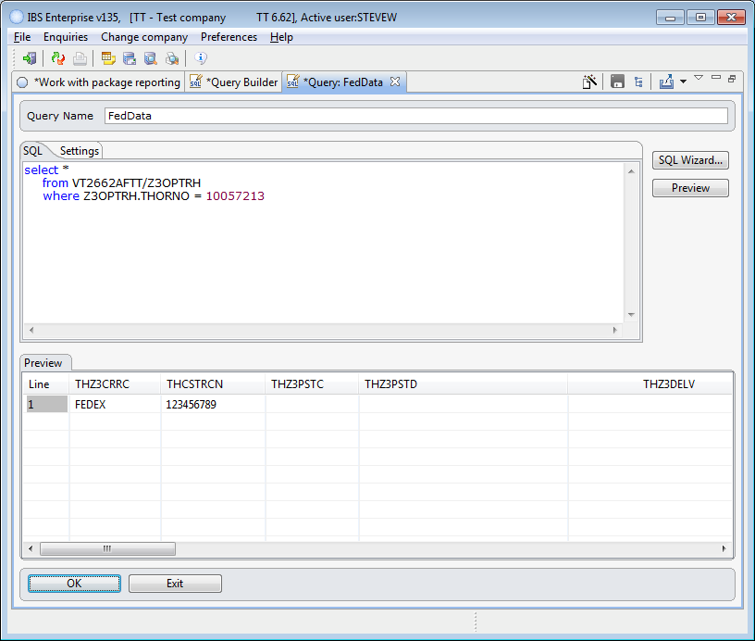When we do this it will change what the user sees on the online system.

